Lab 1 Assignment (Part I) – Managing AD Domains**,** Forests**,** and Trusts

**====================================================================**

Task 1**:** Promote DC407 as a New Domain Controller **in** a New Forest

**----------------------------------------------------------------**

**\*** Explanation**:**

**---------------**

**In** this task**,** I installed the Active Directory Domain Services **(**AD DS**)** role on DC407 and promoted it as the first domain controller **in** a new forest called 'partner07.com'**.** I followed the GUI method as instructed **in** the lab**.**

**\*** Steps Taken**:**

**---------------**

Step 1**:** Install AD DS Role **using** Server Manager

**------------------------------------------------**

I opened Server Manager → Manage → Add Roles and Features

**-** Chose**:** Role-based or feature-based installation

**-** Selected**:** DC407

**-** Selected**:** Active Directory Domain Services **(**AD DS**)**

**-** Confirmed required features and proceeded with installation

**-** Waited **for** the installation to complete

🖼️ Screenshots**:**

**----------------**

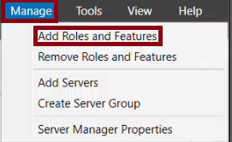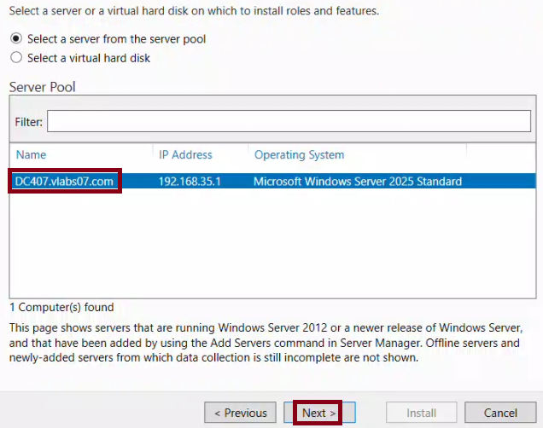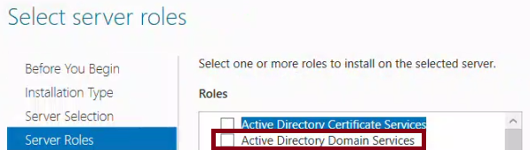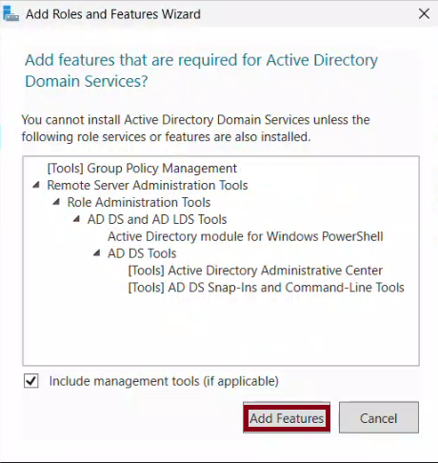

Step 2**:** Promote DC407 to a New Forest

**-------------------------------------**

**-** Clicked on "Promote this server to a domain controller"

**-** Selected**:** Add a new forest

**-** Entered root domain name**:** partner07**.**com

**-** Chose Forest and Domain functional level**:** Windows Server 2025

**-** Ensured DNS Server was checked

**-** Set DSRM password

**-** Left NetBIOS name as default

**-** Accepted default folder locations **for** DB**,** logs**,** and SYSVOL

**-** Reviewed and installed

**-** Server restarted automatically

🖼️ Screenshots**:**

**----------------**

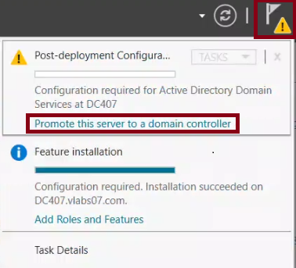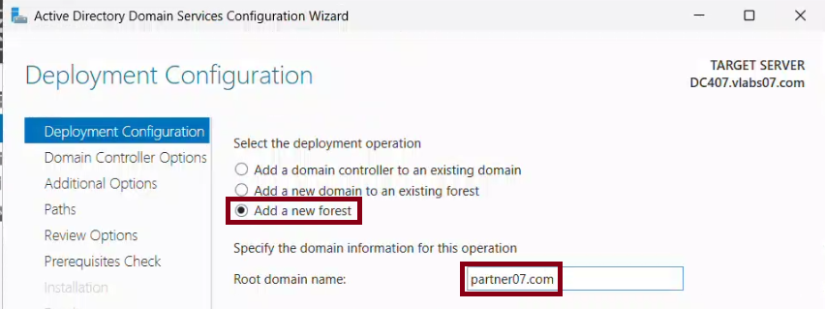

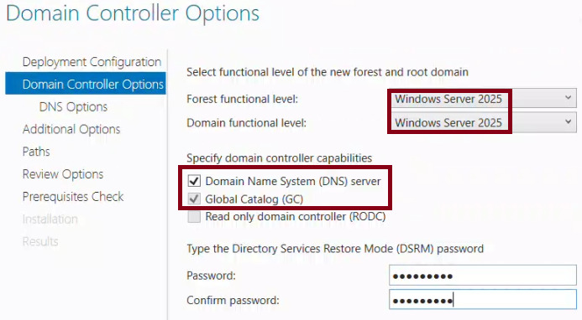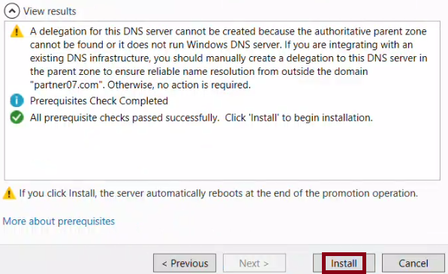

**\*** Verification**:**

**----------------**

After reboot**,** I logged **in** as**:**

Username**:** partner07\Administrator

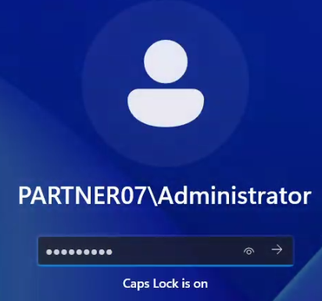

I ran the following command to verify the domain**:**

Get-ADDomain

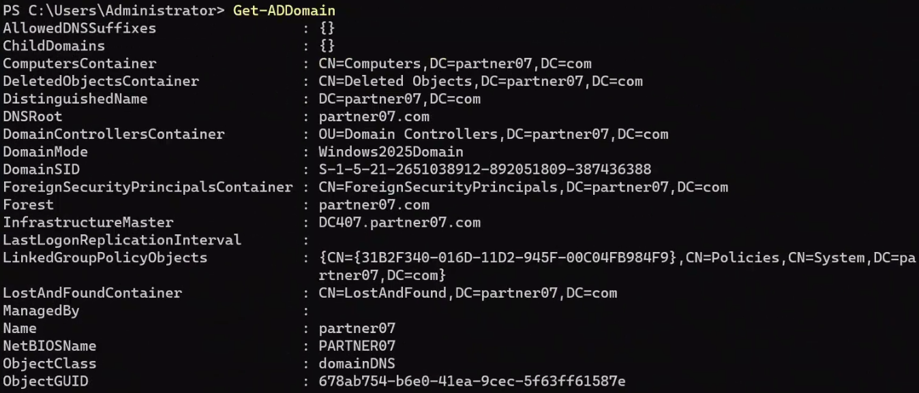

Output confirmed that the domain 'partner07.com' exists and is active**.**

I ran the following command to verify the forest**:**

Get-ADForest

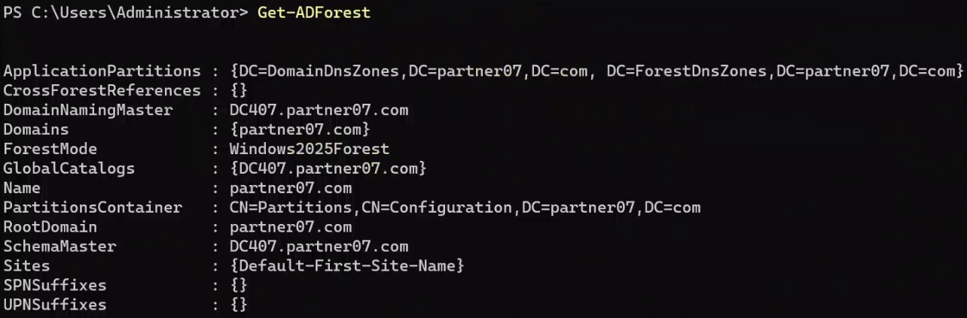

Output confirmed that the forest was successfully created with DC407 as the root**.**

**\*\*** At this point**,** DC407 is the domain controller **for** a brand new forest named partner07**.**com**.** **\*\***

Task 2**:** Verify Domain and Forest Functional Levels

**--------------------------------------------------**

🟩 Explanation**:**

**---------------**

**In** this task**,** I verified the Domain and Forest Functional Levels **for** both**:**

**-** vlabs07**.**com **(**existing domain**)**

**-** partner07**.**com **(**newly created forest**)**

Functional levels control the AD features available across domain controllers**.** Higher levels support newer features but require newer OS versions**.**

I used both GUI **(**ADAC**)** and PowerShell methods to confirm the configuration**.**

🟩 Steps Taken**:**

**---------------**

Step 1**:** On DC107 **(**vlabs07**.**com**)** – GUI Method

**--------------------------------------------**

**-** Opened Server Manager → Tools → Active Directory Administrative Center

**-** **In** the left pane**,** I selected "vlabs07 (local)"

**-** Right-clicked on the domain "vlabs07" and selected "Properties"

**-** The properties window showed**:**

**-** Domain functional level**:** Windows Server 2016

**-** Forest functional level**:** Windows Server 2016

🖼️ Screenshots**:**

**----------------**

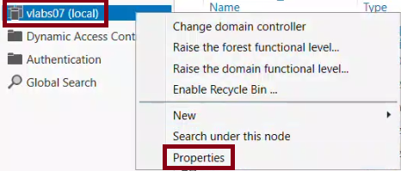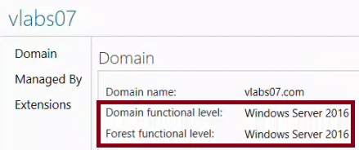

Step 2**:** On DC1XX – PowerShell Method

**-------------------------------------**

Get-ADDomain **|** Select-Object Name**,** DomainMode

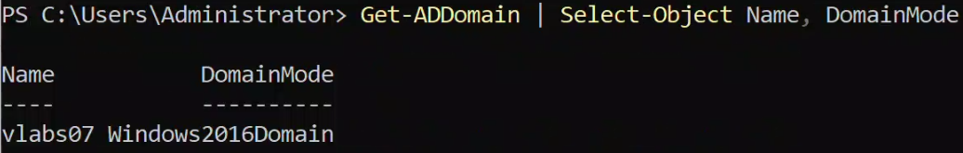

Get-ADForest **|** Select-Object Name**,** ForestMode

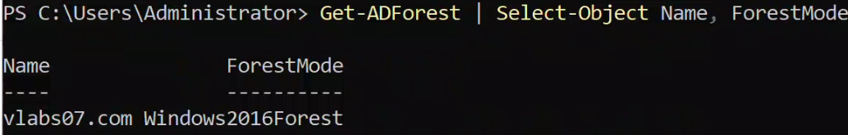

Step 3**:** On DC407 **(**partner07**.**com**)** – GUI Method

**---------------------------------------------**

**-** Repeated the same steps **in** ADAC

**-** Right-clicked domain "partner07" → Properties

**-** Confirmed both functional levels were set to Windows Server 2016

🖼️ Screenshots**:**

**----------------**

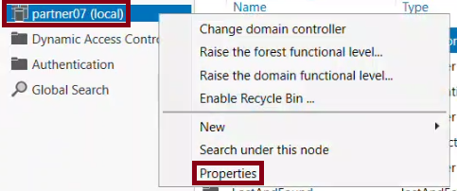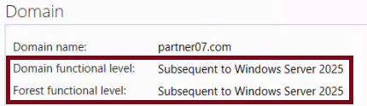

Step 4**:** On DC407 – PowerShell Method

**-------------------------------------**

Get-ADDomain **|** Select-Object Name**,** DomainMode

Get-ADForest **|** Select-Object Name**,** ForestMode

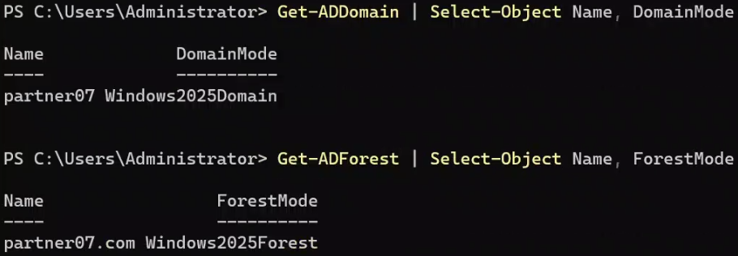

🟩 Verification**:**

**----------------**

The outputs confirmed**:**

**-** vlabs07**.**com is running at Windows Server 2016 domain and forest levels

**-** partner07**.**com is **using** Windows Server 2025 **for** both domain and forest

Task 3**:** Listing Trusts

**-----------------------**

Explanation**:**

**---------------**

**In** this task**,** I listed all the existing trust relationships on both forests**:**

**-** vlabs07**.**com and lab**.**vlabs07**.**com

**-** partner07**.**com

I used two methods**:**

1. GUI**:** Active Directory Domains and Trusts

2. PowerShell**:** **Using** Get-ADTrust cmdlet

Steps Taken**:**

**---------------**

Step 1**:** On DC107 **(**vlabs07**.**com**)** – GUI Method

**--------------------------------------------**

**-** Opened Server Manager → Tools → Active Directory Domains and Trusts

**-** **In** the left pane**,** I right-clicked on "vlabs07.com" and selected "Properties"

**-** Switched to the "Trusts" tab

**-** I saw that this domain has a default trust with its child domain**:** lab07**.**vlabs07**.**com

🖼️ Screenshots**:**

**----------------**

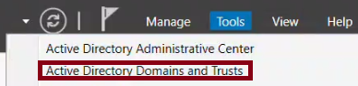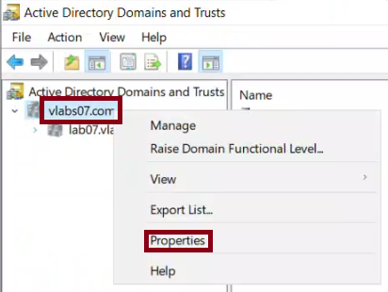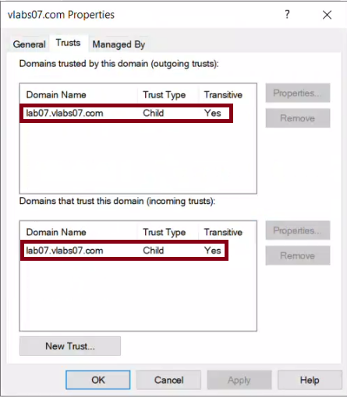

Step 2**:** On DC107 – PowerShell Method

**-------------------------------------**

I ran the following command**:**

Get-ADTrust **-Filter** **\*** **|** Select-Object Name**,** Target**,** TrustType**,** Direction

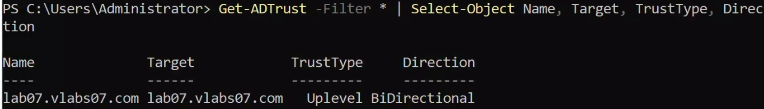

Step 3**:** On DC307 **(**lab**.**vlabs07**.**com**)** – GUI and PowerShell

**--------------------------------------------------------**

**-** Repeated the same steps **using** AD Domains and Trusts

**-** Confirmed any existing trust with the parent domain vlabs07**.**com

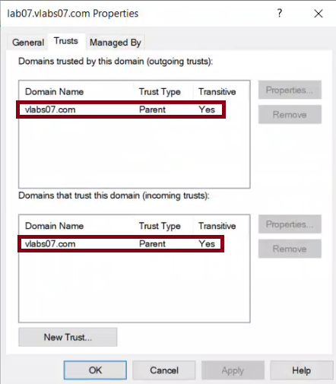

**-** Ran**:**

Get-ADTrust **-Filter** **\*** **|** Select-Object Name**,** Target**,** TrustType**,** Direction

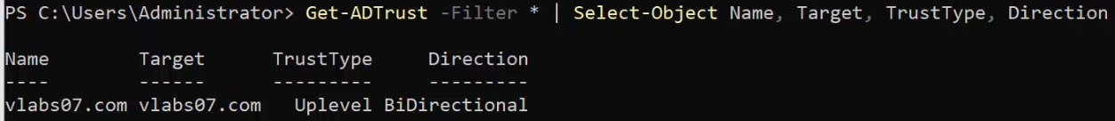

Step 4**:** On DC407 **(**partner07**.**com**)** – GUI Method

**---------------------------------------------**

**-** Opened AD Domains and Trusts

**-** Right-clicked on "partner07.com" → Properties → Trusts tab

**-** Confirmed that no trusts were yet established

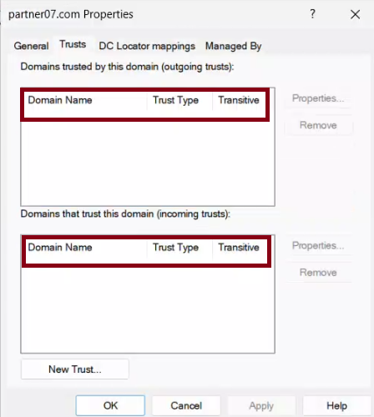

Step 5**:** On DC407 – PowerShell Method

**-------------------------------------**

Get-ADTrust **-Filter** **\*** **|** Select-Object Name**,** Target**,** TrustType**,** Direction



🟩 Verification**:**

**----------------**

All commands confirmed that no trust relationships had been created yet**.**

This matches the lab instructions**,** since the trust will be configured **in** Task 4.

Task 4**:** Creating Trusts

**------------------------**

Explanation**:**

**---------------**

**In** this task**,** I configured DNS Conditional Forwarders so that both domains can resolve each others names**.** Then**,** I created a two-way transitive forest trust between vlabs07**.**com and partner07**.**com**.** I used PowerShell where instructed**,** and GUI where specified**.**

Steps Taken**:**

**---------------**

Step 1**:** On DC107 – Add Conditional Forwarder **for** partner07**.**com **(using** PowerShell**)**

**----------------------------------------------------------------------------------**

I used the IP address of the domain controller **for** partner07**.**com **(**DC407**):**

Add-DnsServerConditionalForwarderZone **-**Name "partner07.com" **-**MasterServers 192.168.35.1 **-**ReplicationScope Forest



Step 2**:** Verify Forwarder on DC107

**----------------------------------**

I ran nslookup from DC107 to ensure partner07**.**com names could be resolved**:**

nslookup partner07**.**com

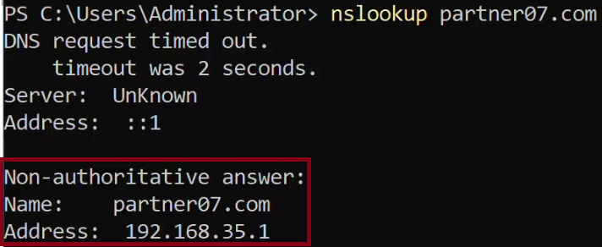

Step 3**:** On DC407 – Add Conditional Forwarder **for** vlabs07**.**com **(using** GUI**)**

**------------------------------------------------------------------------**

**-** Opened Server Manager → Tools → DNS

**-** Expanded DC407 → Right-clicked on "Conditional Forwarders" → New Conditional Forwarder

**-** Entered domain**:** vlabs07**.**com

**-** Added IP**:** 192.168.7.1 **(**IP of DC107**)**

**-** Checked**:** "Store this conditional forwarder in Active Directory" **(**forest-wide**)**

**-** Clicked OK

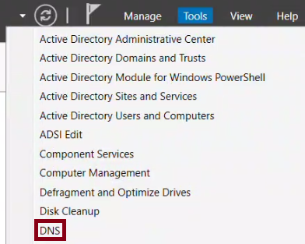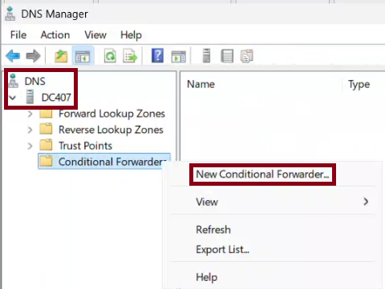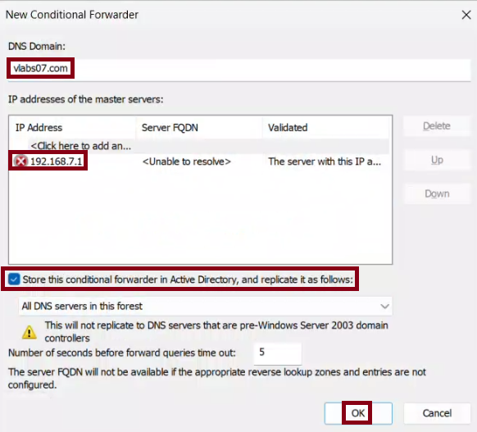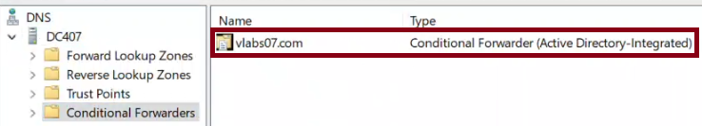

Step 4**:** Verify Forwarder on DC407

**----------------------------------**

From DC407**,** I ran**:**

nslookup vlabs07**.**com

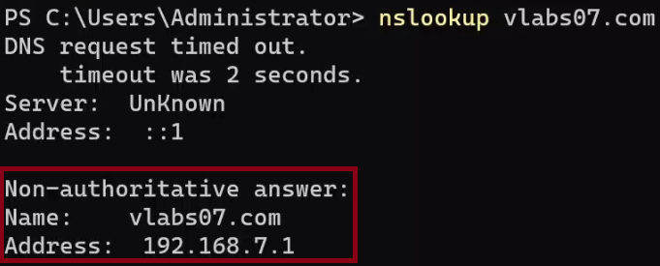

Step 5**:** On DC107 – Create Two-Way Forest Trust **(**GUI**)**

**-----------------------------------------------------**

**-** Opened Active Directory Domains and Trusts

**-** Right-clicked vlabs07**.**com → Properties → Trusts tab → New Trust

**-** Trust name**:** partner07**.**com

**-** Selected**:** Forest Trust → Two-way → Both this domain and the specified domain

**-** Entered credentials **for** partner07\Administrator when prompted

**-** Verified trust was successfully created

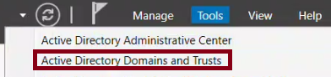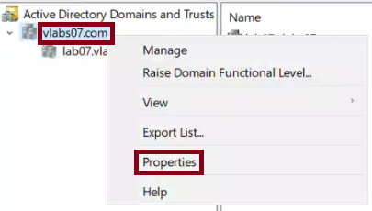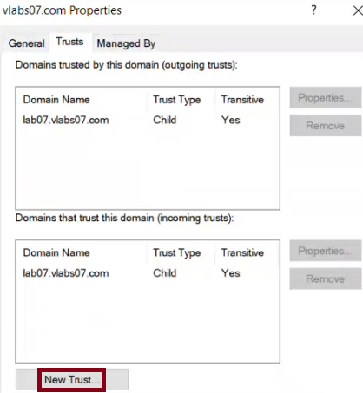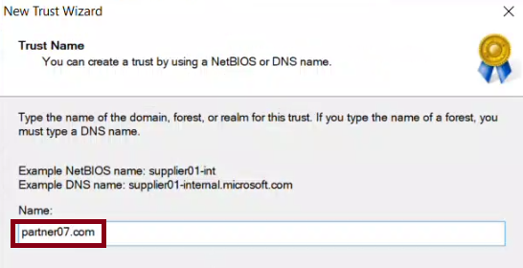

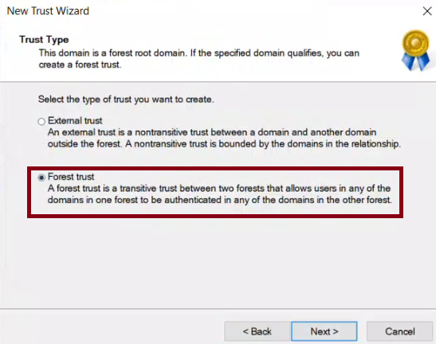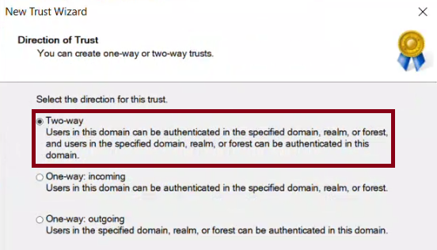

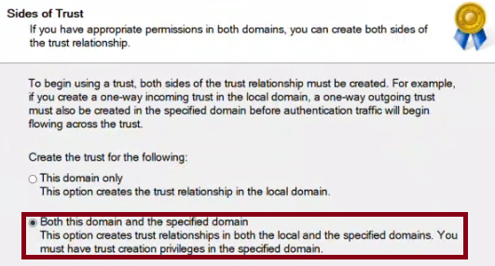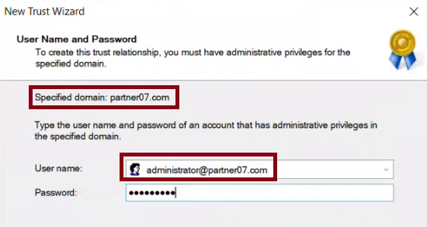

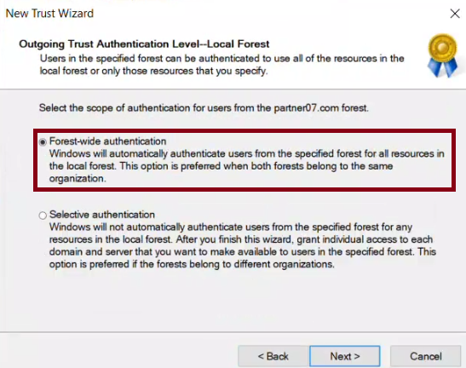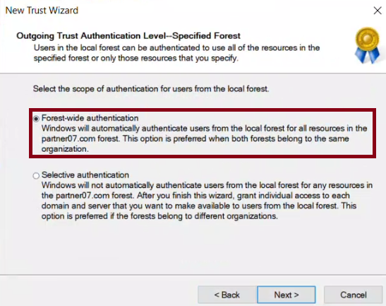

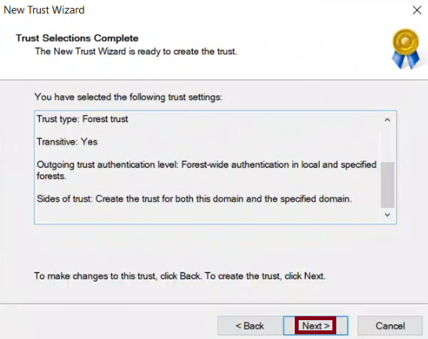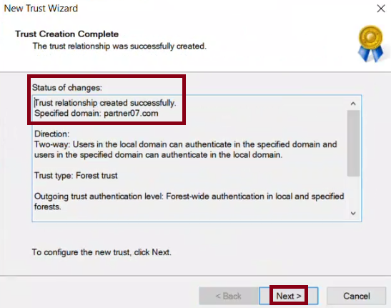

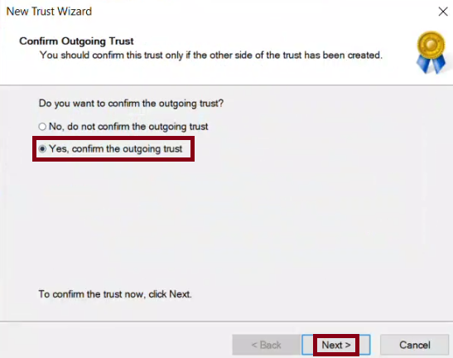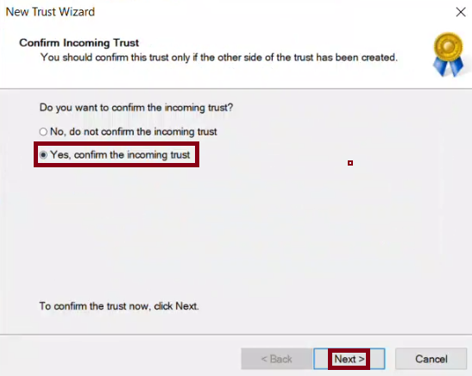

Step 6**:** On DC407 – Verify and Complete Trust Setup **(**GUI**)**

**----------------------------------------------------------**

**-** Opened **\*\***Active Directory Domains and Trusts**\*\*** on DC407**.**

**-** Right-clicked **\*\***partner07**.**com**\*\*** → Selected **\*\***Properties**\*\*** → Navigated to the **\*\***Trusts**\*\*** tab**.**

**-** Verified that **\*\***vlabs07**.**com**\*\*** trust appeared **in** the list**.**

**-** Checked that the status was **\*\***"Trusted"**\*\*** and properties matched the intended configuration**.**

**-** Selected the **\*\***vlabs07**.**com**\*\*** trust entry → Clicked **\*\***Properties**\*\*** → Clicked **\*\***Validate**\*\*.**

**-** **In** the trust validation prompt**:**

**-** Chose **\*\***"Yes, validate the incoming trust"**\*\*.**

**-** Entered credentials **for** **\*\***vlabs07\administrator**\*\*.**

**-** A pop-up appeared prompting to update name suffix routing**:**

**-** Clicked **\*\***Yes**\*\*** to ensure routing of authentication requests **for** any child domains**.**

**-** Validation completed successfully with the message**:**

**\*\***"The trust between vlabs07.com and partner07.com has been successfully verified."**\*\***

📸 Screenshot**:**

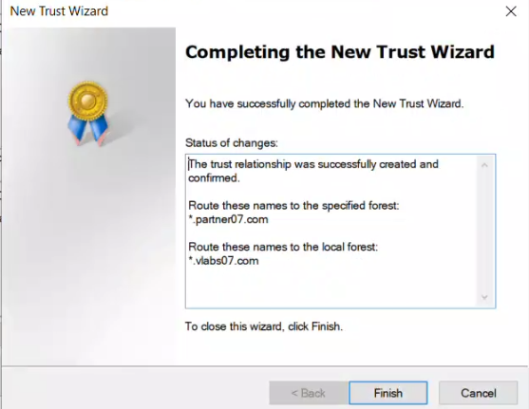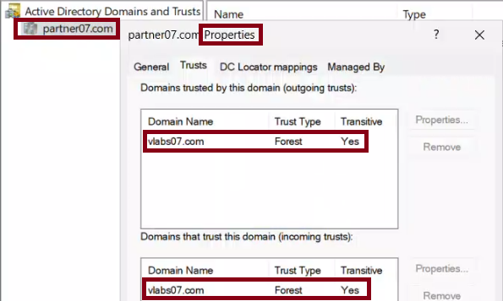

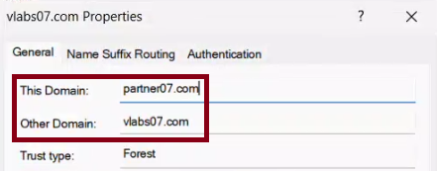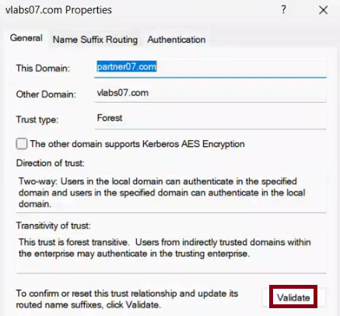

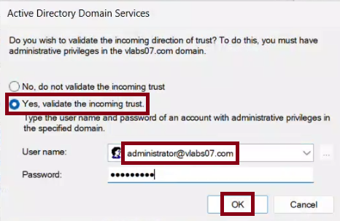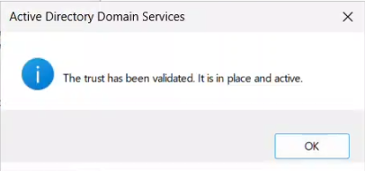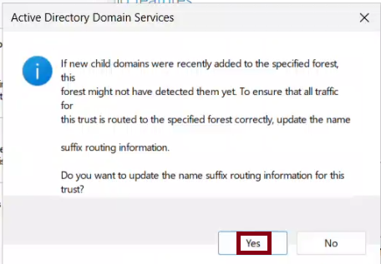

Step 7**:** Verify Trust **Using** PowerShell on Both Servers

**------------------------------------------------------**

Explanation**:**

To confirm that the two-way transitive forest trust between vlabs07**.**com and partner07**.**com is fully functional**,** I used PowerShell and Netdom to verify the trust status from both ends**.**

Actions Performed**:**

**------------------**

1. On **\*\***DC107 **(**vlabs07**.**com**)**:**

**-** Ran the following command to verify the trust**:**

netdom trust **/**d**:**partner07**.**com vlabs07**.**com **/**uo**:**vlabs07\administrator **/**ud**:**partner07\administrator **/**pd**:\*** **/**po**:\*** **/**verify **/**verbose



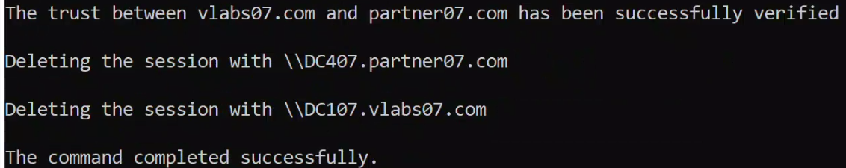

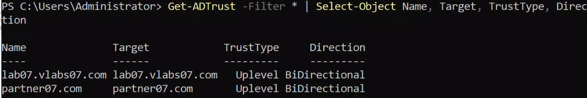

2. On **\*\***DC407 **(**partner07**.**com**)**:**

**-** Ran the matching verification command**:**

netdom trust **/**d**:**vlabs07**.**com partner07**.**com **/**uo**:**partner07\administrator **/**ud**:**vlabs07\administrator **/**pd**:\*** **/**po**:\*** **/**verify **/**verbose



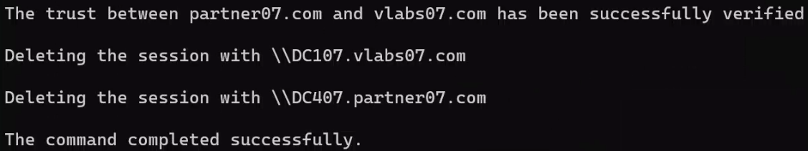

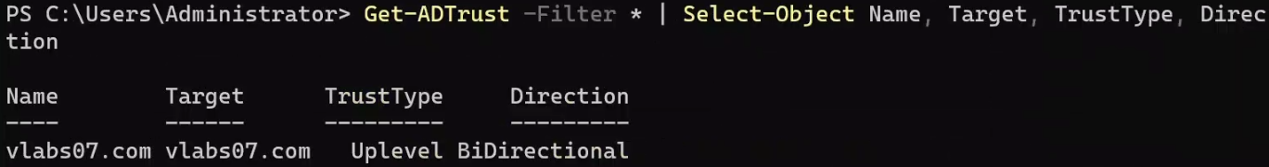

Results**:**

**--------**

**-** On both systems**,** the command returned**:**

**\*\***"The trust between vlabs07.com and partner07.com has been successfully verified."**\*\***

**-** No errors were reported**.**

**-** Trust is fully operational and secured with bidirectional authentication**.**

Task 5**:** Testing Trust Between Two Forests

**-----------------------------------------**

System**:** DC407 **(**partner07**.**com**),** DC207 **(**vlabs07**.**com – RODC**),** Client07

🛠️ Objective**:**

To confirm that the trust is working**,** a user from the partner07**.**com forest will access shared resources **in** the vlabs07**.**com domain **using** their credentials**.**

Step 1**:** Create a User **in** partner07**.**com **(**on DC407**)**

**----------------------------------------------------------**

Create a new user account "Pierre Lima" with the username "p.lima"

New-ADUser

**-**Name "Pierre Lima"

**-**SamAccountName "p.lima"

**-**UserPrincipalName "p.lima@partner07.com"

**-**AccountPassword **(**ConvertTo-SecureString "Passw0rd$" **-**AsPlainText **-**Force**)** `

**-**Enabled **$true**

**-**PasswordNeverExpires **$true**

**-**CannotChangePassword **$true**

**-**Path "CN=Users,DC=partner07,DC=com"

Confirm the user was created:

Get-ADUser plima **|** Select Name**,** SamAccountName**,** Enabled

📸 Screenshot**:**

**-** PowerShell output showing successful user creation and confirmation**.**



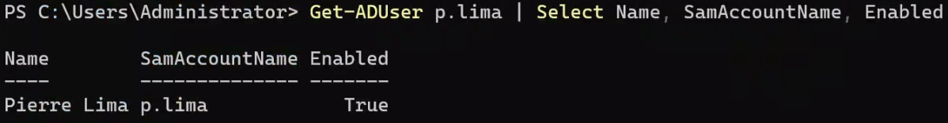

Step 2**:** Share Folder on DC207 **(**vlabs07**.**com – RODC**)**

**--------------------------------------------------**

System**:** DC207 **(**vlabs07**.**com – RODC)

**\***Verify the trust relationship with partner07**.**com*

Check that a trust with partner07**.**com exists and is bidirectional:

Get-ADTrust **-Filter** **\*** **|** Select Name**,** Target**,** TrustType**,** Direction

📸 Screenshot**:**

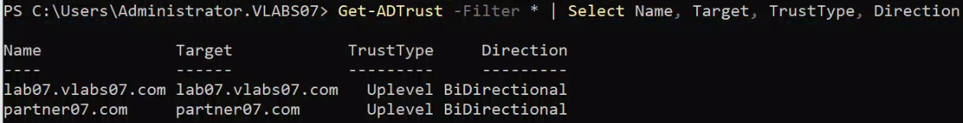

🔹Create a new folder at C**:**\Secret

New-Item **-**Path "C:\Secret" **-**ItemType Directory

📸 Screenshot**:**

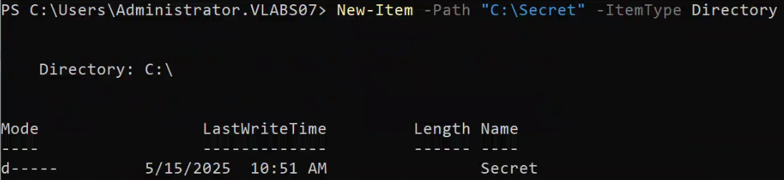

🔹Create SMB Share and Grant Share Permissions

Create the SMB share **(**initial share creation without assigning access yet**)**

New-SmbShare **-**Name "Secret" **-**Path "C:\Secret"

📸 Screenshot**:**



Grant share-level permissions with Change **(**Read**/**Write**)** access to the remote user from partner07**.**com

Grant-SmbShareAccess **-**Name "Secret" **-**AccountName "partner07\p.lima" **-**AccessRight Change **-**Force

📸 Screenshot**:**

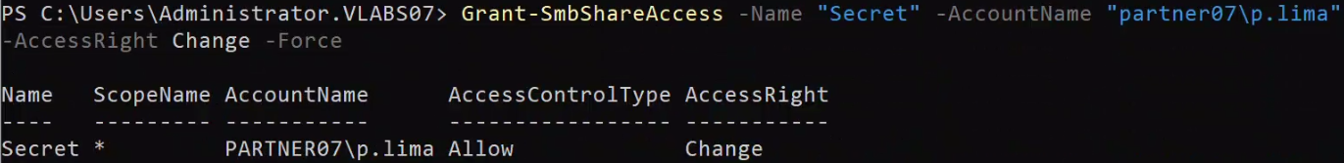

# Note: The lab instructions mention assigning permissions to p.laurin,

# but since only p.lima was created in Step 1, all permissions were applied to that user instead.

🔹 Set NTFS permissions

**\***Get current NTFS permissions **(**ACL**)** on the folder

This stores the current access control settings **for** C**:**\Secret **in** the **$acl** variable

**$acl** **=** Get-Acl "C:\Secret"

📸 Screenshot**:**



**\***Create a new permission rule **for** partner07\p**.**lima

This rule grants Modify **(**Read**/**Write**)** permission**,** inheritable by subfolders and files

**$rule** **=** New-Object System**.**Security**.**AccessControl**.**FileSystemAccessRule**(**

"partner07\p.lima"**,** "Modify"**,** "ContainerInherit,ObjectInherit"**,** "None"**,** "Allow"

**)**

📸 Screenshot**:**



**\***Add the new rule to the ACL object

This updates the ACL **in** memory by adding the rule **for** partner07\p**.**lima

**$acl.**AddAccessRule**($rule)**

📸 Screenshot**:**



**\***Apply the updated ACL back to the folder

This writes the new permission settings to the actual folder on disk

Set-Acl **-**Path "C:\Secret" **-**AclObject **$acl**

📸 Screenshot**:**



**\***Verify Share and NTFS Permissions Before Proceeding

**----------------------------------------------------**

Confirm the SMB share exists

Get-SmbShare **-**Name "Secret"

📸 Screenshot**:**

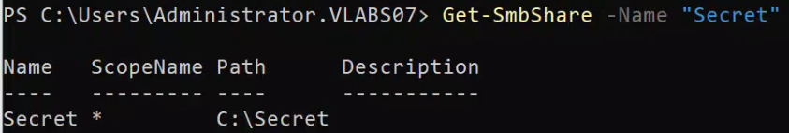

**\***Confirm the share access permissions

Get-SmbShareAccess **-**Name "Secret"

📸 Screenshot**:**

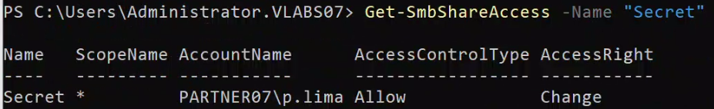

**\***Confirm NTFS **(**file system**)** permissions **for** the user

This command retrieves all access control entries **(**ACEs**)** **for** C**:**\Secret

and filters the results to show only those related to "p.lima"

**(**Get-Acl "C:\Secret"**).**Access **|** Where-Object **{** **$_.**IdentityReference **-**like "*p.lima*" **}**

📸 Screenshot**:**

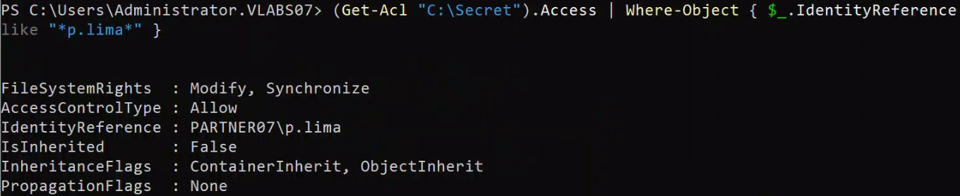

Step 3**:** Test Access from Client07

**----------------------------------**

Log **in** to Client07 as**:**

Username**:** p**.**lima@partner07**.**com

Password**:** Passw0rd**$**

📸 Screenshot**:**

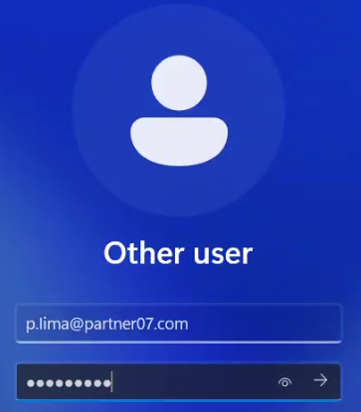

🔹 Map the shared folder as a network drive **(**Drive S**:)**

Command**:**

New-PSDrive **-**Name "S" **-**PSProvider "FileSystem" **-**Root "\\DC207\Secret" **-**Persist

Explanation**:**

**-** New-PSDrive**:** Creates a new logical drive **(**like a mapped network drive**).**

**-** **-**Name "S"**:** This assigns drive letter S**:** to the mapped location**.**

**-** **-**PSProvider "FileSystem"**:** Tells PowerShell youre mapping a file system drive**.**

**-** **-**Root "\\DC207\Secret"**:** The network path to the shared folder created earlier**.**

**-** **-**Persist**:** Makes the drive visible **in** File Explorer and survive reboots **(**like GUI mapping**).**

📸 Screenshot**:**

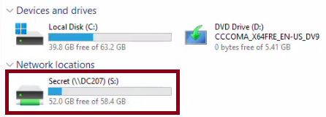

🔹 Create a test file **in** the shared folder to verify write access

Command**:**

New-Item **-**Path "S:\testfile.txt" **-**ItemType "File"

Explanation**:**

**-** New-Item**:** Creates a new file or folder**.**

**-** **-**Path "S:\testfile.txt"**:** The full path to the new file inside the mapped drive**.**

**-** **-**ItemType "File"**:** Specifies that a file should be created **(**not a folder or shortcut**).**

📸 Screenshot**:**

